BASEBALL CROSS
Barrie Community Sports Complex
Sunday, November 2nd, 2025 – Presented by:


October 27, 2025
Technical Guide
Version 2

Table of Contents
Table of Contents 2
Event Description 3
OC Event Contacts 4
Commissaires 4
Registration 5
Pre-Riding 5
Event Schedule 6
Category Charts 6
Category Equivalency Chart 7
Food and Beverage 7
Awards & Prizes 7
Event Rules 8
Ontario Cup Call-Up Protocol 10
Medical/Hospitals 12
Appendix 13
Course Map 13
Team Area 14
Results & Timing 14
Safety and First Aid 14

Event Description
Date: Sunday, November 2nd, 2025
Time: 7:30 am – 3:00 pm
Location: Barrie Community Sports Complex: 2100 Nursery Rd, Minesing, ON L0L 1Y2
Parking: Entry & exit to the park are located off Nursery Rd, within the park follow the Ontario Cycling parking signs to the lot at the back of the park near the tent camping area. Vehicles found outside of the designated parking lot will be required to relocate their vehicle and could potentially be towed if blocking the roadway and/or a resident of the property.
Pit/Tech Zone: The pit will be dual sided and located approximately halfway through the lap of the course to offer riders 2 opportunities for servicing/bike changes per lap.

OC Event Contacts
Position | Name
Event Organizer | Trevor O’Donnell
Ontario Cycling Event Lead | Darren De Ruiter
Membership/Licensing | Chris Baskys
Timing | racetiming.ca
Medical | Odyssey Medical

Commissaires
Position | Name
President of the Commissaire Panel | Marie-Eve Potvin
Finish Judge | Maria Paisley
Member | Kevin Scheerer

Registration
- Registration for all CX races is open to Ontario Cycling members and license holders 8 years of age and older.
- UCI License holders, Challenge/Compete Members, and non-members (subject to an additional one-day fee) are permitted to participate at all events. Out-of-Province riders must have a UCI License. Licenses will not be sold on event day and must be purchased in advance.
- Registration closes on Thursday, October 30th at 11:59pm.
- If the Thursday at 11:59pm registration deadline passes and a rider would still like to register, they have until Friday at 4:00pm to contact the OC office for registration to be re-opened and may be subject to a $50 late entry fee.

Baseball Cross Registration
Event | Registration Timeline | Link
Baseball Cross | Closes Thu, October 30th @ 11:59pm | HERE
Cost per event | Price of $40-70 depending on category
*Riders looking to register for both a geared and single speed category can do so by selecting multiple categories when registering online. Adding single speed to your cart will trigger a 25% discount to be applied to both registrations, simulating a reduction of $35 off the individual single speed registration to be $35 for the add on. Day of registration for single speed and all categories is not allowed.

Pre-Riding
Course pre-riding is available on race day Sunday, November 2nd. 20-to-30-minute time breaks between start waves have been worked into the schedule to allow all riders to have an equal opportunity to ride 1 or more laps of the course prior to their race start. Riders are only permitted to pre-ride the course when either no race is currently on the course or behind the last rider in the current race on course on their final lap. Pre-riders must not interfere with the current race unfolding, any riders who are found to have interfered with or passed the last rider of the current race on course may be subject to receiving a fine or disqualified from competing in their race later in the day. Any person who rides the course outside of race day assumes their own risk and responsibility when riding.

Event Schedule
Sunday, November 2nd:
- 7:30 am – 1:00 pm Rider Sign-In is Open*
- 9:00 am Start Wave 1 - Master Men/Open (45+) & Cat D
(17+)
  - 10:15 am: Wave 1 Podium Ceremonies
- 10:00 am Start Wave 2 - U17, U15, & U13 Girls/Boys)
  - 11:15 Am: Wave 2 Podium Ceremonies
- 11:00 am Start Wave 3 - Cat B (17+) & Cat C (17+)
  - 12:30 pm: Wave 3 Podium Ceremonies
- 12:15 pm Start Wave 4 - Cat A Women (17+), Cat B Women
(17+), & Master Women (35+)
  - 1:45 pm: Wave 4 Podium Ceremonies
- 1:30 pm Start Wave 5 - Cat A (17+) & Single Speed (17+)
  - 3:00 pm: Wave 5 Podium Ceremonies

*All riders must sign-in at the Pavillion before their race. Sign-in closes 30 minutes prior to the start of each race wave.

Category Charts
Start Time | Category  Age as of Dec 31, 2026 | Duration | Registration Fees  Closes Thu, Oct 30
9:00 AM | Master Men/Open (45+) | 40 minutes | $70
9:01 AM | Cat D (17+) | 40 minutes | $70
9:40 AM | Break | 20 minutes
10:00 AM | U17 Girls & Boys | 40 minutes | $40
10:01 AM | U15 Girls & Boys | 30-40 minutes | $40
10:02 AM | U13 Girls & Boys | 30-40 minutes | $40
10:40 AM | Break | 20 minutes
11:00 AM | Cat B (17+) | 45 minutes | $70
11:01 AM | Cat C (17+) | 45 minutes | $70
11:45 AM | Break | 30 minutes
12:15 PM | Cat A Women (17+) | 45 minutes | $70
12:16 PM | Cat B Women (17+) | 40 minutes | $70
12:16 PM | Master Women (35+) | 40 minutes | $70
1:00 PM | Break | 30 minutes
1:30 PM | Cat A (17+) | 60 minutes | $70
1:31 PM | Single Speed (17+) | 45 minutes | $70 ($35 if you register for another category in addition to Single Speed)

Category Equivalency Chart
To aid in transition to the updated category system please see below equivalency chart to get an idea of what categories would be the best fit based on the category a rider most recently competed in:
Category Equivalency Chart
2024 Category |  | 2025 Recommended Categories
Elite 3 Women | ➡️ | Cat B Women
Elite 1/2 Women | ➡️ | Cat A Women
Master Women | ➡️ | Cat A/B Women or Master Women (35+)
Elite 4 Men | ➡️ | Cat C or D
Elite 3 Men | ➡️ | Cat B or C
Elite 1/2 Men | ➡️ | Cat A
Master 3 Men | ➡️ | Cat D or Master Men (45+)
Master 2 Men | ➡️ | Cat B or C or Master Men (45+)
Master 1 Men | ➡️ | Cat A or B

Food and Beverage
The Sports Complex with have a vendor open to all riders and guests. They will be selling food and beverage to some capacity.

Awards & Prizes
- Medals will be awarded to the top three (3) finishers in each category.
- Fastest Lap of the day for men and women will receive a prize, doesn’t matter what race of the day! (last year was brand new tubulars and xt pedals)
- Should categories be combined because of low participation numbers, results will be broken out for awards. Awards will be awarded based on the results of each category separated.
- Riders must attend the awards ceremonies or risk forfeiting their awards.
- Podium protocol shall be enforced, and fines may be issued to those who fail to comply. Riders must wear their competition uniform for medal presentations.
- Medal presentations will take place following the conclusion of each race.

Event Rules
General Rules & Regulations
- The races will be governed under the current UCI Cyclo-Cross rules as amended by CC and OC. CC and OC rules are available online at https://ontariocycling.org/commissaire-resources/
- The UCI penalty scale with CC and OC modifications will be used for any infractions
- All riders must sign-in at registration on race day at least 30 minutes prior to their start.
- US licensed racers must hold a UCI International license. For insurance reasons, a USA cycling license is not sufficient and is not permitted in Canada.
- All foreign licensed riders, other than US riders must produce a letter of permission from their country’s federation. This must be submitted to Ontario Cycling 72 hours in advance of the event and a copy must be provided on race day to the President of the Commissaire Panel.
- Riders must have a valid Provincial Race or UCI license to participate.
- An OC representative will be present at the race to assist with rider licensing issues. Licenses will not be sold on race day.
- Proof of license purchase (i.e., receipt) is not a sufficient proof of license and will not be accepted on race day.
- Races will start promptly at the indicated start times.
- Warming up on the course while a race is taking place is prohibited. As the lead rider crosses the finish line riders will be advised that they may enter the course at a point just beyond the finish and must not interfere with racers completing their last lap. Please be courteous to other racers above all else.
- Rider staging will begin 10 minutes prior to race start and call-ups 5 minutes prior. If you are not present for call-up you will forfeit your starting position.
- Any rider dropping out of the race shall immediately notify a commissaire. If you drop out of a race and do not report to a commissaire, you will be considered and unreported DNF and assessed a penalty.
- A double wheel pit is located on course for servicing equipment and changing bikes or wheels. The pit must be accessed by the designated entrances and riders may not travel backwards or cut the course to reach the entrance, with the exception of a mishap occurring after the pit entrance but before the pit exit (travel back to pit entrance in this case).
- There is no neutral service provided. Riders must supply their own spare wheels or bicycles.
- Lapped riders may be pulled at the order of the commissaire, either after being overtaken or just before being overtaken.
- The 80% rule will be enforced at the discretion of the President of the Commissaire Panel.
- All riders finish on the same lap as the winner. The ringing of a bell will indicate the last lap.
- Results will be posted near registration shortly after each race.
- Upon posting there will be a 15-minute protest period after which time, the results will become official and award presentations will follow promptly.
- In case of lightning, the race may be delayed or cancelled. If you are informed that the race has been stopped due to lightning, you are advised to seek shelter until the race can resume. No refunds will be issued if the race is cancelled. If there are any changes or delays in the schedule.
- Consumption of alcohol by riders or spectators on site is strictly prohibited unless it is explicitly stated by the event organizing committee (alcohol permit and insurance coverage obtained). Any rider seen consuming alcohol may be subject to a fine or disqualified from the event.

Equipment Regulations
- Cyclocross bicycles conforming with UCI regulations are required in the Cat A categories. In particular:
  - A bicycle shall not measure more than 185cm in length and 50cm in overall width.
  - Mountain bikes or bikes with flat-bar handlebars are not permitted.
  - Width of the tire shall not exceed 33mm and it may not incorporate any form of spike or stud.
  - All other categories allow the use of any bicycle; including mountain bikes provided bar end are removed to be used.
- Riders are required to wear jerseys corresponding with the club or team printed on their license. Independent riders and unlicensed riders are required to wear a plain jersey with no significant logos, team names, or advertising displayed on them.
- Sleeveless jerseys are not permitted.
- At all times when warming up or participating in the event, riders who are mounted on a bicycle shall wear a helmet at all times.
- Two-way radios are reserved for race organization only.
- The use of radio links or other remote means of communication with the riders is forbidden.
- Riders may not use any form of radio communication while competing.
- Helmet mounted cameras are not permitted.
- The use of personal music players are not permitted while racing or warming up on the course.
- The use of glass containers is strictly prohibited during the race

Staging & Start Protocol
- Riders will start in a Mass Start Format according to the above schedule.
- Start Corrals to open 10 minutes prior to start. Riders are reminded to follow instructions for maintaining proper distancing.
- Race Officials will start each wave of the race.

Call-Up Protocol
Call-ups are designed to encourage participation in the OCup series by Ontario riders. OCup races use ability-based categories:
- Call-ups will be done by OCup points only for the first 2 rows.
- Riders tied with the same number of OCup points will be randomized.
- After the first 2 rows are filled, the rest of the riders will fill the remaining places on a first-come, first-served basis.
- If the first 2 rows are not filled, other riders can take open positions there.
- When two or more categories are combined in the same start wave (that is, start at the same time offset), those riders will be considered “in the same race”. Call-ups will cycle between each category to fill the first 2 rows (1st, 1st, 1st, 2nd, 2nd, 2nd, 3rd, 3rd, 3rd, 3rd, etc.)

Organizers may wish to publicly acknowledge National, World Champions or other celebrity riders in their race. These acknowledgments will be done before the call-ups. Participants will then be called up following the procedure above only. There is no penalty if a rider saves a place and allows another rider to move up to take it (riders may choose any position after their call-up).

Youth Categories:
- Youth categories will be called up based on OCup points separately by U17 Boys, U17 Girls, U15 Boys, U15 Girls, U13 Boys, U13 Girls (ties broken randomly). Combined gender race starts will be called up in the order of 1st Boy, 1st Girl, 2nd Boy, 2nd Girl, 3rd Boy, 3rd Girl and so forth unless it is agreed upon otherwise between all riders and the commissaires in advance of the start.
- Call-ups for each category will be for the first 2 rows only. When the first 2 rows are filled, the rest of the riders will fill the positions on a first-come, first-served basis. If the first 2 rows are not filled, other riders in the same category can take open positions there.
- Each category shall begin in a new row. Half-wheeling between rows is not permitted.

Technical Assistance Regulations
- Riders should be prepared to work on their bicycle outside of the pit area. They can receive assistance in the pit area only.
- Spare bicycles and wheels are allowed in the pit area only.
- Riders are required to supply their own parts and equipment in the technical assistance zone. Riders may not take other participants equipment without their permission.
- Riders may carry tools and spare parts, provided that these do not involve any danger to the rider themselves or other competitors.
- No rider may turn back on the course to reach the pit area.
- Only those persons responsible for assisting riders may be in the pit area. Spectators, children, and pets are not permitted in the pit area. Spectators may watch from outside of the course.

Bad Weather and Course Changes
- Changes to the course may be required in case of severe weather or changing atmospheric conditions. Changes will be announced at the start of all races. In all conditions riders should ensure they are riding within their limits and dismount if the terrain exceeds their technical comfort level.
- In the case of severe weather requiring a change of schedule, an email will be sent out to all participants, and information will be posted on Ontario Cycling’s social media accounts.
- View OC’s Weather Policy & Guideline Here

Medical/Hospitals
Royal Victoria Regional Health Centre: 201 Georgian Dr, Barrie, ON L4M 6M2

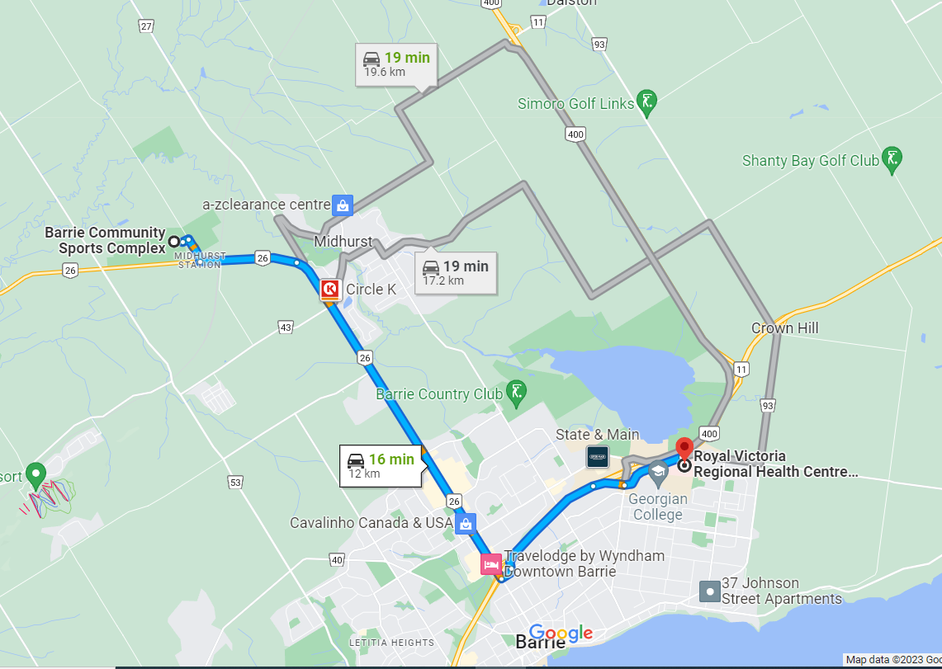
Directions to Closest Hospital
Barrie Community Sports Complex: 2100 Nursery Rd, Minesing, ON L0L 1Y2
- Turn right onto Nursery Rd
- Turn left onto ON-26 E
- Slight right onto Bayfield St N/ON-26 E (signs for Barrie)
- Turn left onto Rose St
- Take the ramp onto ON-400 N
- Take exit 102 for Duckworth St
- Continue straight on Georgian Dr
- The destination will be straight ahead
Royal Victoria Regional Health Centre: 201 Georgian Dr, Barrie, ON L4M 6M2

Appendix

Course Map
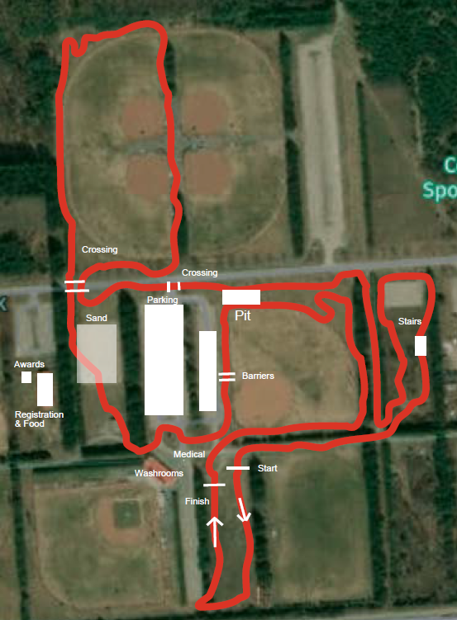

Team Area
There is limited space at Barrie Community Sports Complex for the set-up of Team Tents during the event. Register for team space by emailing a request to todonnell396@hotmail.com. Failure to register for team space may result in a refusal of team area at the event, due to limited space.

Bib Numbers
- One set of bib numbers will be distributed per rider for the race
- Please ask for a second timing chip for your pit bike. All timing chips are to be returned at the end of race completion.
- Bibs are to be placed on both arms and the RIGHT back side of the jersey. Please refer to below diagram.
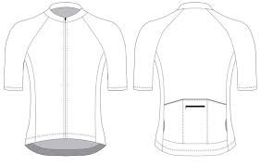
4
4
4

Results & Timing
Racetiming.ca will be providing timing for the event.

Safety and First Aid
First Aid will be provided by Odyssey Medical. They will be stationed near the start/finish area and at strategic location(s) on course at the discretion of the First Aid provider. Course maintenance volunteers will be on course at all times to make sure the competition area maintains consistent for all races.

